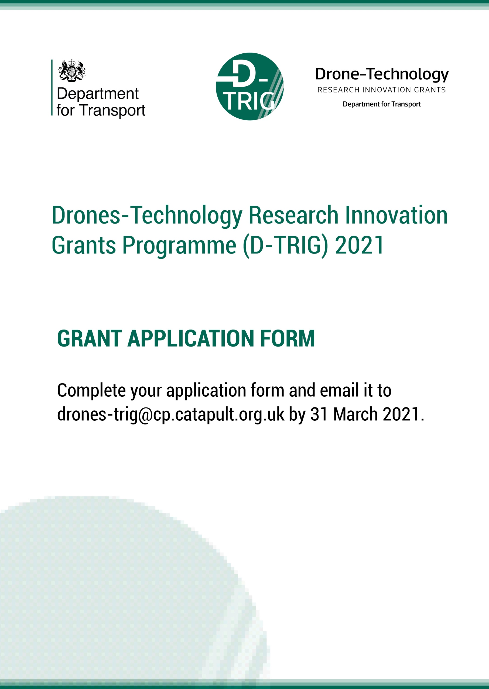

Project Title
Company/Organisation Name

SECTION 1
AWARENESS OF D-TRIG COMPETITION
1 | How did you learn about the D-TRIG competition?
Previous experience of applying for TRIG programmes ☐
DfT website ☐
Twitter ☐
LinkedIn ☐
Informed by CPC (Connected Places Catapult) ☐
Informed by KTN (Knowledge Transfer Network) ☐
Informed by EPSRC (Engineering and Physical Science Research Council). ☐
Media (i.e. online news, newspaper) ☐
(please specify) Click here to enter text.

Other social media channels ☐
(please specify) Click here to enter text.

Other ☐
(please specify) Click here to enter text.

COMPANY/ORGANISATION INFORMATION
2 | Full company name  (If this application is successful, this is the name that will be used in publicity, unless an alternative name is clearly specified here). | Click here to enter text.
3 | Registered office address | Click here to enter text.
4 | Company registration number | Click here to enter text.
5 | Company VAT registration number | Click here to enter text.
6 | What size is your company? | Choose an item.
7 | How many employees are there in the company? | Choose an item.
8 | Is your company revenue generating? | Choose an item.
9 | Name of your immediate parent company (if applicable) | Click here to enter text.
10 | Are you collaborating with another company, organisation or authority? If you answer Yes, please provide details below.  Click here to enter text. | Choose an item.

COMPANY/ORGANISATION CONTACT
11 | What is your name? | Click here to enter text.
12 | What’s your position in the company? | Click here to enter text.
13 | E-mail address | Click here to enter text.
14 | Telephone number | Click here to enter text.
15 | Finance contact (for providing financial documents) | Click here to enter text.
16 | Finance contact’s telephone and email address | Click here to enter text.

DUE DILIGENCE
17 |  | Are you able to provide a copy of your accounts for the last two years, if requested? | Yes ☐  No ☐
18 |  | Has your organisation or any of its officers, employees or other persons associated with it been convicted of any offence involving slavery and human trafficking? | Yes ☐  No ☐
19 |  | Do you have a policy or statement that sets out the steps your organisation has taken to ensure that slavery and human trafficking is not taking place in any of your supply chains or in any part of your own business? | Yes ☐  No ☐
 |  | If you have answered “No” to question 19, please provide a summary of the actions you are taking to ensure the eradication of slavery and human trafficking within your supply chain or in any part of your business.
Summary of actions
Click here to enter text.
20 |  | Does your organisation comply with your statutory obligations under the Equality Act 2010? | Yes ☐  No ☐
21 |  | In the last three 3 years, has any finding of unlawful discrimination been made against your organisation by an Employment Tribunal, an Employment Appeal Tribunal or any other court (or in comparable proceedings in any jurisdiction other than the UK)? | Yes ☐  No ☐
22 |  | In the last three 3 years, has your organisation had a complaint upheld following an investigation by the Equality and Human Rights Commission or its predecessors (or a comparable body in any jurisdiction other than the UK), on grounds or alleged unlawful discrimination? | Yes ☐  No ☐
 |  | If you have answered “Yes” to one or both of questions 21 or 22 above, please provide a brief summary of the nature of the investigation and an explanation of the outcome of the investigation to date. If the investigation upheld the complaint against your organisation, please also explain what action (if any) you have taken to prevent unlawful discrimination from reoccurring
Summary
Click here to enter text.
23 |  | Has your organisation or any of its Directors or Executive Officers been in receipt of enforcement or remedial orders in relation to the Health and Safety Executive (or equivalent body) in the last three 3 years? | Yes ☐  No ☐  N/A ☐
 |  | If your answer to question 23 is “Yes”, please provide details of any enforcement/remedial orders served and give details of any remedial action or changes to procedures you have made as a result
Details and remedial action
Click here to enter text.
24 |  | Does your organisation have a Health and Safety Policy that complies with current legislative requirements? | Yes ☐  No ☐  N/A ☐
25 |  | Does your organisation have an in-house policy for the management of Environmental issues? | Yes ☐  No ☐  N/A ☐
26 |  | Has your organisation been convicted of breaching environmental legislation, or had any notice served upon it, in the last three 3 years by any environmental regulator of authority (including Local Authority)? | Yes ☐  No ☐
 |  | If your answer to question 26 is “Yes”, please provide details of the conviction or notice and details of any remedial action or changes you have made as a result of conviction or notices served.
Details and remedial action
Click here to enter text.
27 |  | Does your organisation have an in-house policy for the management of Quality issues? | Yes ☐  No ☐
28 | Please confirm that you have and will maintain the following insurances.  - Public liability Choose an item.  - Professional indemnity Choose an item.  - Employer’s insurance Choose an item.

CONFLICT OF INTEREST
29 | This is a Pass/Fail question. If an applicant cannot or is unwilling to suitably demonstrate that they have suitable safeguards to mitigate any conflict of interest, then their application will be deemed non-compliant and they will NOT be considered for this competition.
 | Do you have any potential, actual or perceived conflicts of interest that may be relevant to this competition? | Yes ☐  No ☐
 | If answered Yes in D.1, please provide details of any potential, actual or perceived conflicts of interest in respect of this project and outline what safeguards would be put in place to mitigate this risk arising during the project.
Click here to enter text.

FUTURE OPPORTUNITIES
30 | Can the DfT or Connected Places Catapult (CPC) contact you about other innovation research competitions? | Yes ☐  No ☐
31 | If your application is successful, the DfT would also like to share your project details with partners who may be interested in working with you to progress the results of the project. Please tick if you are content for the DfT to share your project details with others listed below.  Note: Details will only be shared if you give permission by ticking the boxes below.  Innovate UK ☐  Transport or Local Authorities ☐  Knowledge Transfer Network ☐  Other Government Departments ☐  Other ☐

PREVIOUS APPLICATIONS
32 | Have you ever applied to TRIG or any other DfT funded Programme? | Yes ☐  No ☐
If Yes, please tell us which programme, your project title, and the year in which you applied.
Click here to enter text.

SECTION 2
Please refer to the Application Guidance document before completing this section.
33. PROJECT TITLE (one sentence)

34. PROJECT SUMMARY (600 characters max.)
Your summary should outline exactly what your project will entail.

35. Please indicate which TRL your technology is currently at.
☐ TRL 1: Idea stage. Basic principles observed.
☐ TRL 2: Basic research; technology concept formulated.
☐ TRL 3: Experimental proof of concept achieved.
☐ TRL 4: Small scale prototype; technology validated in a lab or testing environment.
☐ TRL 5: Large scale prototype; technology validated in an operational environment.
☐ TRL 6: Technology demonstrated in operational environment.
☐ TRL 7: Prototype demonstration in operational environment.
☐ TRL 8: First of a kind commercial system; all technical processes to support commercial activity are in a ready state.
☐ TRL 9: Full commercial application; technology is readily available on the market.

36. If applicable, please tell us the transport mode that your technology applies to.
☐ Road
☐ Rail
☐ Maritime
☐ Aviation
☐ Micro-mobility
☐ Cross or multi-modal

37. The Challenge (3,000 characters max.)
What is the challenge being addressed by the proposed project? Please provide details of any activities undertaken to validate the challenge that your application will address.

38. Innovation (5,000 characters max.)
How is your application innovative?

39. Project Management and Team (4,000 characters max.)
Please outline your plan for delivering a successful project. Your plan must include the key milestones, resource allocation to tasks, skills and expertise within the team, health and safety management, ethics approval process (where required) and details of the key risks that will need to be managed (including those arising from the COVID-19 pandemic).

40. Please upload a Gantt chart to support your project outline.

41. Will your project be concluded by NOV 2021
☐Yes
☐No

42. Exploitation – Route to Market (3,000 characters max.)
Please provide details of how you intend to bring your product or service to market following successful demonstration through this programme.

43. Please upload any images, diagrams or figures to support this section.

44. Project Finances
Please provide details of how much the project will cost to deliver and how the budget will be spent to ensure value for money. This section can be edited.
Use this table to detail your costings for the project. List each person involved, along with their daily rate and number of days worked. Also include other costs, such as equipment, material and contracting.
Name of employee and company if in collaboration | Daily rate | Number of days per employee | Total budget (£)
 | £ |  | 0
 | £ |  | 0
 | £ |  | 0
 | £ |  | 0
Consultancy costs (£) |  |  | 0
Material costs (£) |  |  | 0
Equipment cost (£) |  |  | 0
Laboratory/testing cost (£) |  |  | 0
Other expenses (£) (please specify) |  |  | 0
A. Total Cost (£) |  |  | 0
B. Total funding sought from D-TRIG (£) |  |  | 0
If the total project cost (A) is greater that the funding being sought (B) please explain how you plan to fund the difference.

46. Please use this section to provide a commentary of your project finances (if you would like to).

SECTION 3
47. SUBSIDIES
The organisation acknowledges that the Programme is funded by the Department for Transport and that the grant funds are therefore public monies. Consequently, the award of such monies must be done in a manner compliant with subsidy rules under the EU-UK Trade and Cooperation Agreement. Any monies awarded to the organisation under the Programme will not constitute a ‘subsidy’ provided the organisation does not receive more than 325,000 Special Drawing Rights (approximately £344,600) of state support over a rolling 3 fiscal year period.

If the organisation’s application for grant funding under the Programme is acceptable, the organisation will be required as part of its acceptance of the Grant Offer to complete a ‘no subsidy’ declaration confirming that the amount of grant awarded to the organisation will not cause it to exceed the limit of 325,000 Special Drawing Rights of state support over a rolling 3 fiscal year period.
Please tick the box to confirm that you do not anticipate that any grant award under the Programme will cause the organisation to contravene the de minimis state aid limit ☐

48. TERMS AND CONDITIONS
Please tick this box to confirm that you have reviewed the terms of the Grant Agreement and that you accept them ☐
Having examined the Application Guidance Document (and FAQ’s) and Grant Agreement, I hereby submit our application on the full understanding that any resulting Grant Offer shall be subject to the provisions of the Funding Agreement and I accept these terms and conditions.

I certify that the information set out in this Grant Application Form is true and complete. I understand that if any of this information is subsequently discovered to be false or misleading the organisation’s participation in the Programme may be terminated and any funds paid to the organisation may be required to be repaid.
Name:
Company:
Position:
Signature:
Date:

49. Equality and Diversity Monitoring
The Department for Transport and the Connected Places Catapult are collecting equality, diversity and inclusion (ED&I) data to promote and ensure equality of access for its grant funding competitions and programmes. This data will help us monitor performance of efforts to promote ED&I in research and business innovation. Therefore, we would be very grateful if you could spend a few minutes completing this questionnaire.

Please click here to complete the survey.

